Sequence Diagram: Communities Page

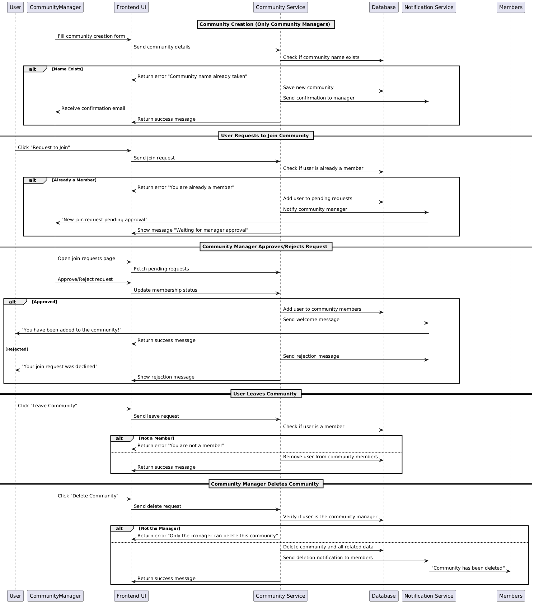

Database:
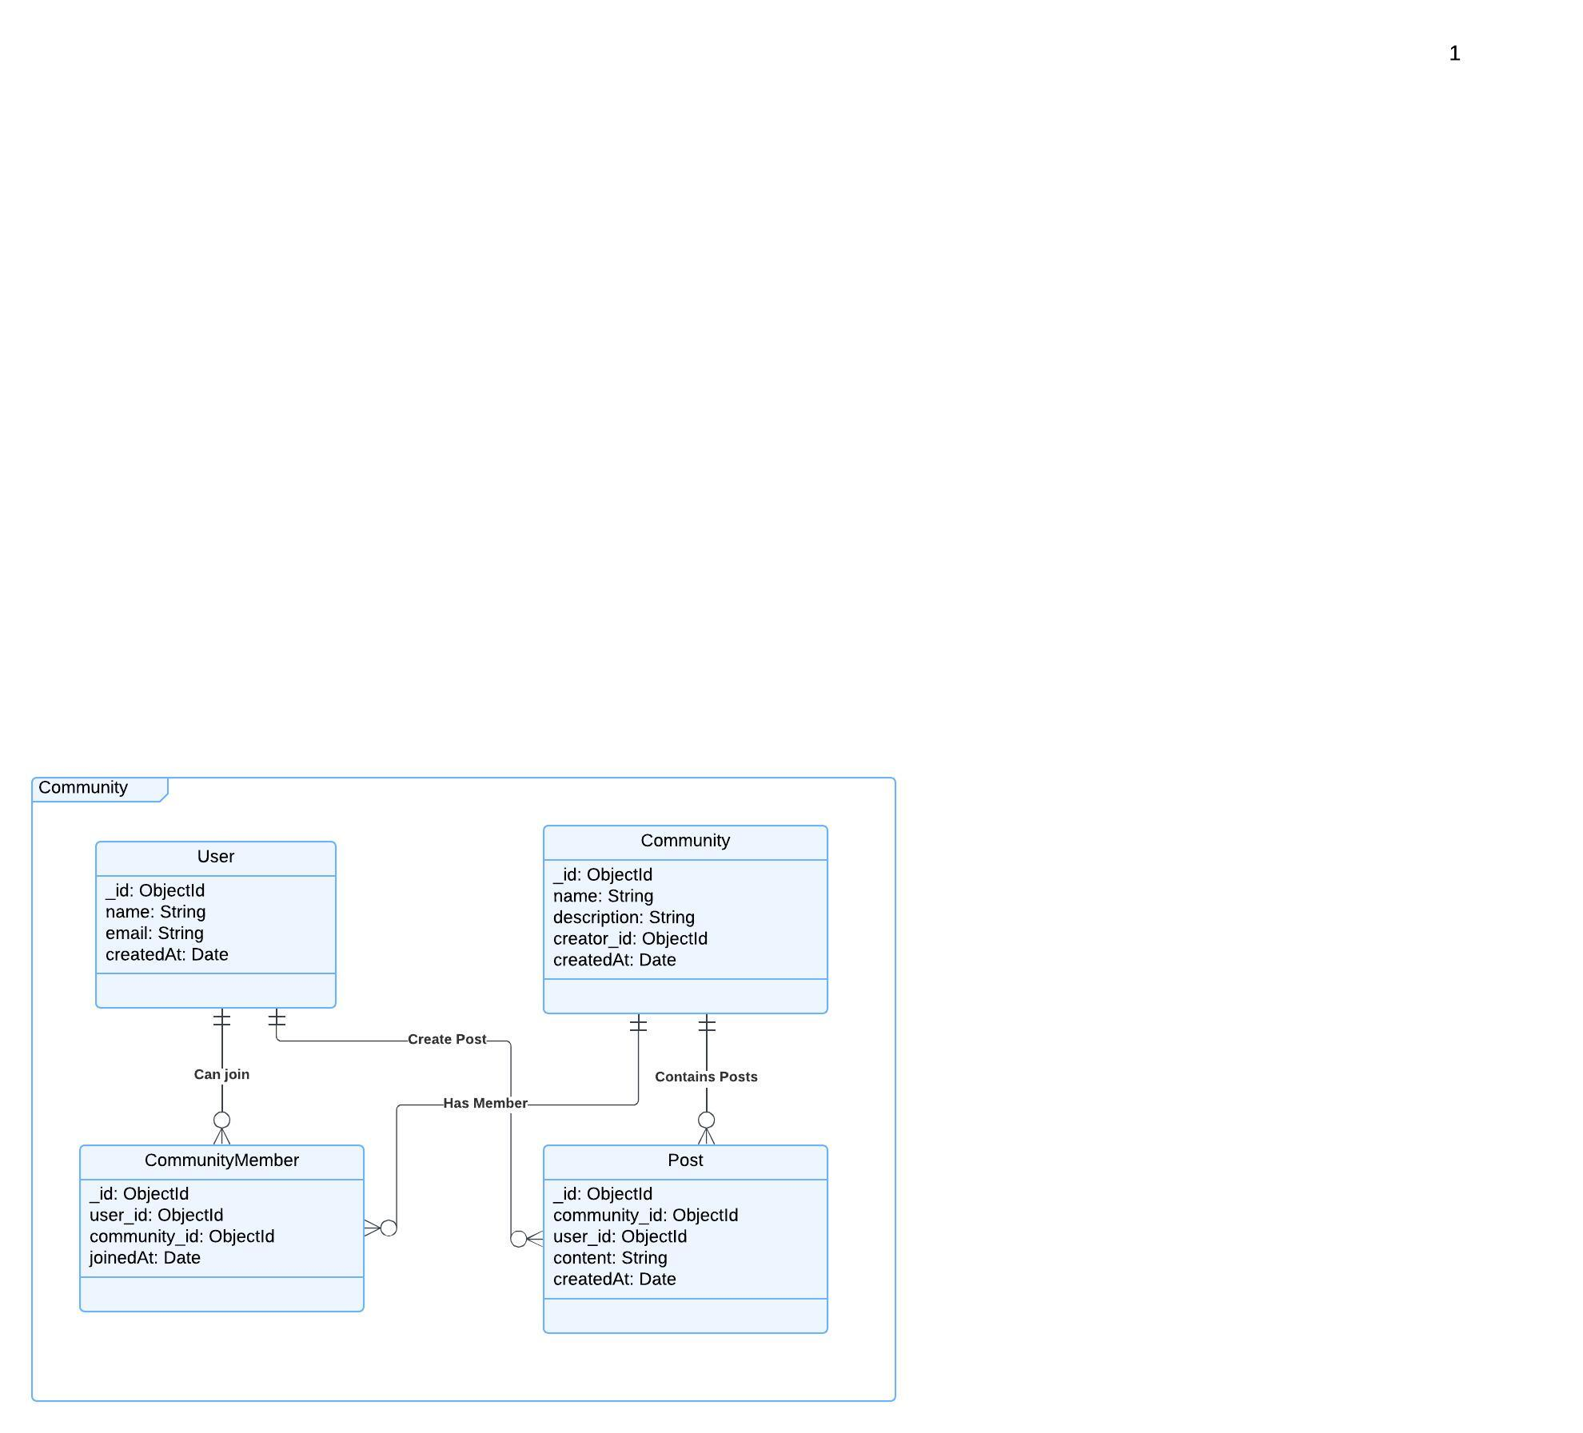

Functional Requirements (FRs)
Community Creation (Only Community Managers)
- FR1: The system shall allow Community Managers to create a new community by providing the required details (e.g., name, description).
- FR2: The system shall validate that the community name is unique before allowing the creation of a community.
User Membership in Communities
- FR3: Users shall be able to join a community by clicking the "Join Community" button.
- FR4: The system shall validate that the user is not already a member of the community.
- FR5: If the user is already a member, the system shall display an error message: "You are already a member."
- FR6: Upon successful joining, the system shall add the user to the community and send a welcome message.
User Leaving Community
- FR7: Users shall be able to leave a community by clicking the "Leave Community" button.
- FR8: The system shall remove the user from the community members list upon confirmation.
- FR9: The system shall display a success message upon successfully leaving the community.
Community Deletion (Only Community Managers)
- FR10: Community managers shall be able to delete a community they manage.
- FR11: The system shall validate that the user requesting the deletion is the Community Manager.
- FR12: If the user is not the community manager, the system shall display an error message: "Only the manager can delete this community."
- FR13: Upon deletion, the system shall remove all community data, including member records and posts, from the database.

Non-Functional Requirements (NFRs)
Performance & Reliability
- NFR1: The system shall process the community creation request within 3 seconds to provide a smooth user experience.
- NFR2: The system shall process user join/leave requests within 2 seconds for a fast response.
Usability
- NFR3: The user interface shall be simple and intuitive for both Community Managers and users.
- NFR4: The system shall display clear error messages for users attempting actions they are not authorized for (e.g., trying to delete a community without manager rights).
- NFR5: The community creation and management interface shall be responsive and work well on both desktop and mobile devices.

Security
- NFR9: Only authenticated users with proper permissions (Community Managers) shall be allowed to create or delete communities.
- NFR10: The system shall ensure that users can only join communities they are not already a part of and cannot perform unauthorized actions like deleting communities they don't manage.

